The Impact of Health information Exchange on Health Care Organizations

Nikitha Thota
HINF 5101: Introduction to Health Informatics
Professor Catherine Turner
Northeastern University
November 23, 2025

The Impact of Health Information Exchange in Healthcare
Overview
This paper explores the Role of Health Information Exchange, its importance, applications and benefits in the clinical world to enhance Quality and coordinated care. During the course of this study, we analyze two different health care organizations and their interrelationships with HIE vendors. We also dive into the evolution of Health Information Exchange, the impact of the current technological landscape on HIE & Health Care Organizations and the future of Health Information Exchange in enhancing patient-centered care.

Introduction
Health information sharing has not always been digital like it is today. Earlier, the method of sharing the information was paper based. This paper-based exchanging of information presented a lot of challenges in finding, maintaining and keeping the data in a secure way as this is highly sensitive data (Esmaeilzadeh, 2023). These challenges along with the digital revolution led to the development of Electronic Health Records (EHR). Storing data in a structured format in EHRs simplified data exchange between health care providers. However, the lack of a centralized or universally practiced format still posed some challenges in exchanging information electronically across different organizations. Health Information exchange (HIE) is the sharing of comprehensive patient health information electronically between different providers and Healthcare organizations collected from diverse healthcare facilities (Esmaeilzadeh et al., 2020).
“Interoperability is the ability of different information systems, devices and applications (systems) to access, exchange, integrate and cooperatively use data in a coordinated manner, within and across organizational, regional and national boundaries, to provide timely and seamless portability of information and optimize the health of individuals and populations globally” (Healthcare Information and Management Systems Society, 2025). Bates & Samal (2018) notably recognized that HIE exists without true interoperability, interoperability requires the potential to consume shared data and not just exchange information.
Lack of full interoperability between healthcare systems leads to data being trapped and fragmented. The persistence of fragmented health data results in medical errors like adverse drug reactions, increased healthcare costs, lack of receiving timely information, incoordination among providers and delays in diagnosis. This in turn adversely affects the patient outcomes.
Current Interoperability Adoption
“The Office of National Coordinator (ONC) at Health IT since 2014, started tracking the four widely recognized domains of interoperable exchange: Send, Receive, Find and Integrate” (Gabriel et al., 2024).
Figure 1
Illustration of four domains of Interoperable Exchange
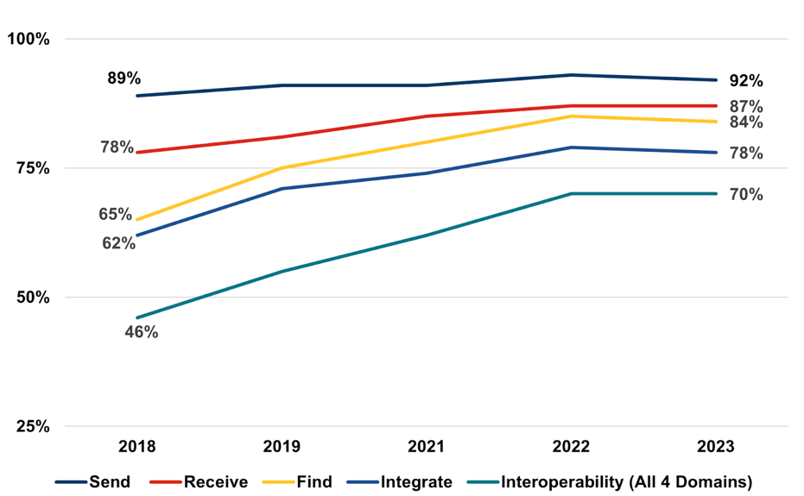

Note: This graph represents the percentage of hospitals meeting the four domains mentioned by ONC from 2018 to 2023. Taken from “Interoperable Exchange of Patient Health Information Among U.S. Hospitals: 2023” (ONC, 2024)
Hospitals are classified to be routinely engaged if they often meet these four domains and are classified as sometimes interoperable when they only sometimes engage in the four domains. Though the adoption of EHRs has significantly increased in the United States (96%), interoperability is only at 70% in 2023. Of this 70%, “less than half of hospitals (43%) routinely engaged in interoperable exchange, while 27% sometimes engaged in interoperable exchange” (Gabriel et al., 2024).

Figure 2
Illustration of the percentage of frequency of Non-federal Acute Care Hospitals engaging in Interoperable Exchange.
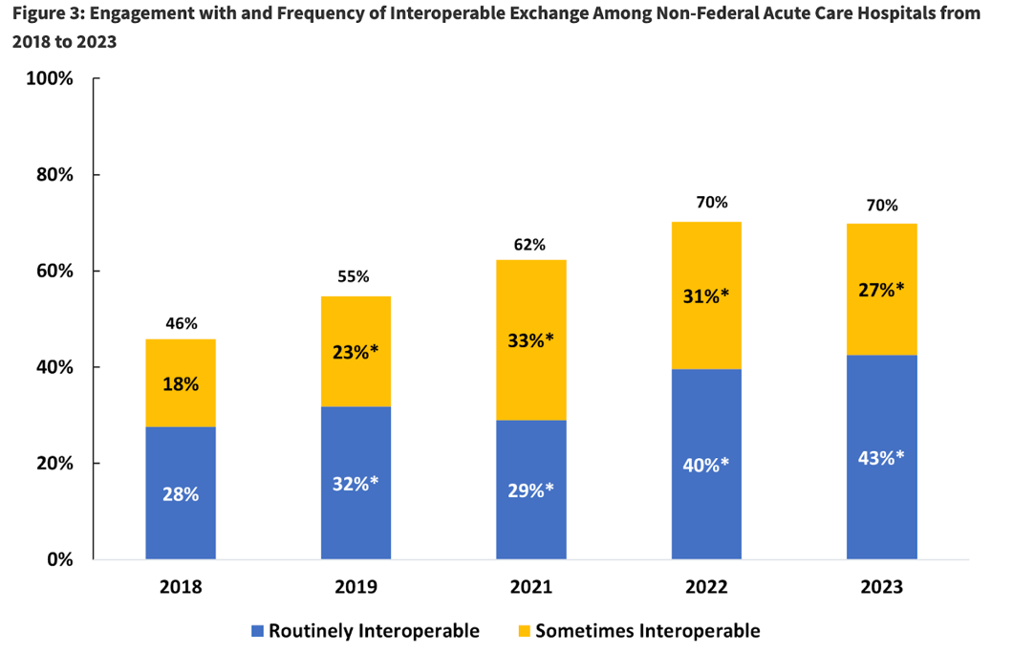
Note: This graph represents the Percentage of frequency of Routine and Sometimes interoperable exchange from 2018 to 2023. Taken from “Interoperable Exchange of Patient Health Information Among U.S. Hospitals: 2023” (ONC, 2024)

Evolution of Health Information Exchange
Health information Exchange has evolved significantly over time to achieve smoother flow of electronic information between different systems. It started with Paper-based sharing, rise of EHRs, Community Health Information Exchanges, Regional Health information Organizations (RHIOs), Statewide Health Information Exchanges and National Health Information network (NHIN). The regional and statewide health information exchanges focus on intra region and intra state information exchange and “its success has inspired the US government to come up with an interoperable nationwide health information network (NHIN)” (Dixon et al., 2010).

Critical Components of Health Information Exchange
For HIE to operate efficiently, the key components include “Health information systems, interoperability standards and Health Information Exchange platform” (Bria, 2025). Different healthcare organizations use different health information systems that better suit their needs. For example, a hospital stores patient data in EHRs, a laboratory will store patient data in Laboratory Information systems (LIS), Pharmacy similarly stores patient data in Pharmacy Information Systems (PIS). Interoperability standards in HIE help the health care information systems to meaningfully use this exchanged data. The four types of Interoperability are “Foundational (Level 1), Structural (Level 2), Semantic (Level 3) and Organization (Level 4)” (Healthcare Information and Management Systems Society (HIMSS), 2025). Foundational interoperability enables secure exchange of patient health information between systems. Structural interoperability is facilitated by the data standards which ensures the data is represented in a standard format between both the systems and includes examples like Health Level Seven (HL7). Semantic interoperability establishes shared language and terminology standards to ensure different systems interpret the data in the accurate and meaningful way. Organizational interoperability includes policies and governance to enable seamless flow of data between and within organizations (HIMSS 2025, Nelson 2023).
Standards in HIE are “the agreed upon guidelines that ensure uniformity and consistency in the way day is structured, transmitted and interpreted” (Bria, 2025). These standards include content standards which define the format of the data being exchanged like HL7, Consolidated Clinical Document Architecture (C-CDA). Identifiers standards are used by information systems to securely identify and verify patients and other systems via Medical Record Number and Master Patient Index. Health Insurance Portability and Accountability Act (HIPAA) upholds Privacy and security standards to protect data privacy security. Terminology standards facilitate semantic interoperability by defining common vocabulary and terminology for the data to be exchanged and interpreted meaningfully. Transport standards facilitate foundational interoperability data is transported and includes examples like “Digital Imaging and Communication in Medicine” (DICOM), Fast Healthcare and interoperability Resources (FHIR) (HIMSS, 2025). Finally, the Health Information Exchange platform is the platform that facilitates the actual data exchange, interoperability between information systems while withholding all the standards of HIE (Bria, 2025).
Key Modalities and the exchange of Data
The Sermo team (2022) clearly elucidated the three fundamental forms of the HIE as “Directed Exchange, Query Based Exchange and Consume based exchange”.
Directed Exchange is a way of information exchange that allows the sharing and receiving of secure patient health information between providers “via encrypted, secure, and reliable messaging” (Office of the National Coordinator for Health Information Technology (ONC), 2019) and is used in regular care benefitting patients from the coordinated care (ONC, 2019). This is often used for sending referrals, lab results and discharge summaries of the patients. To achieve HIPAA security standards, direct information exchange relies on Health Information Service Provider (HISP). HISP is a vendor responsible for verifying, identity, encrypting critical information and establishing a secure way of direct communication between the verified providers. Even with HISP, direct information exchange still deals with interoperability challenges as it does not guarantee the format in which the data is actually exchanged (Definitive Healthcare, 2025).
“Query-based exchange enables providers to request or find patient information from other providers within a network and is used in unplanned care like in emergency situations” (ONC, 2019). This is helpful in fetching comprehensive patient health information. In a query-based health information exchange, the requestor (EHR system) sends a query to fetch the required comprehensive patient health information in HIE. HIE then locates the patient documents within the trust network via Master Patient Index (MPI) or Record Locator Service (RLS) (Carequality, 2021). The patient data is sent back in standard formats like C-CDA, CCD, but is not automatically converted if they are stored in unstructured formats.
Consumer-mediated exchange places patients at the center of their own health data. It lets them oversee and share their complete medical information with different providers, correct inaccuracies in clinical or billing records, and stay actively involved in tracking and managing their health over time (Sermo Team, 2022).
This form of exchange enhances patient engagement mainly addressing the underserved people who are affected by limited access to healthcare and “facilitates transparency and patient-centric care” (Civitas Networks for Health, 2025).

Federal policies for strengthening Interoperability
The ONC had developed the Trusted Exchange Framework and Common Agreement (TEFCA) “to provide a framework for Health Information Networks across the country” (ONC, n.d.) by creating rules and legal structure to enable nationwide sharing of health information to improve care coordination. QHINs are designated entities which become “central exchange nodes and facilitate nationwide data exchange. QHINs are selected via a rigorous on-boarding process led by Recognized Coordinating Entry” (ChartRequest, 2025).
The 21st century Cures Act established regulations that prohibit information blocking and made sharing electronic health information a norm and this law is applied to healthcare providers, HIE’s, HIN’s and health IT developers. It is done to advance interoperability & enhance accessibility, usability, and privacy & security of HIT (ONC, n.d.).
The 2024 Center for Medicare and Medicaid Services (CMS) Interoperability and Patient Access Final Rule framework emphasizes structural interoperability and aims to improve seamless data exchange between different systems mandating certain payers to adopt common standards like FHIR APIs and USCDI (United States Core Data for Interoperability) (Lo et al., 2025).
The HITECH Act of 2009 introduced financial incentives to encourage healthcare providers to adopt certified electronic health records and to advance the meaningful use of health information technology. In doing so, it indirectly promoted voluntary participation in health information exchange efforts (Healthcare Compliance Journal, 2025).
The ONC’s Health IT Certification Program, a voluntary federal initiative, which mainly requires EHRs to meet a certain standard for exchange of data defined by ONC. “A final rule issued in 2020 involved the United States Core Data for Interoperability (USCDI), a standard set of data classes for describing the health data that may be exchanged” (Lo et al., 2025) See Appendix table for USCDI V6 summary.
Health Information networks adopting the CMS interoperability framework, exchange data through FHIR APIs, complying with “US Core FHIR implementation guide, including full FHIR capabilities statement and USCDI V3 (or later) with terminology compliance by July 4, 2026” (CMS, 2025).
Benefits of Achieving Interoperability and HIE
Adoption of HIEs provides a wide range of benefits to providers, patients, payors, public health and research. With HIE, healthcare providers can easily access and obtain timely patient health information allowing them to make accurate clinical decisions at the point of care. Access to real-time patient information reduces manual workload and improves the administrative workflow. Helps providers to have a view of comprehensive health information including medication history, allergies reducing the medical errors and duplicate tests thereby reducing the healthcare costs. (Bria, 2025). It also benefits public health departments and researchers by having hospitals share the information on infectious diseases to them through HIE and supports case investigations to monitor and track, identify the patterns of the disease outbreaks (Texas Health and Human Services Commission, n.d.).
“HIEs can also notify the public health agencies when an individual taking treatment for an infectious disease discontinues and reappears at an emergency hospital, which allows them to follow-up and help resume the treatment” (Civitas Networks for Health, 2023).
Patient-centric exchange allows patients to access their health information through patient portals, encouraging them to be involved in the health care decisions and “share their medical information with multiple healthcare organizations” (Esmaeilzadeh et al., 2024).

Manifest MedEx and Adventist Health
“Manifest Medex is a California based non-profit statewide Health Information Exchange and also a Qualified Health Information Organization (QHIO) formed in 2017” (Manifest MedEx, n.d.). It serves 3300 plus California Healthcare organizations, 140 plus Hospitals and has access to 50 million patient records. Manifest Medex’s mission is to give as much as information access to improve healthcare outcomes, care and reduce healthcare costs. Its main office is in Riverside, California and has several branches and affiliations. Manifest MedEx has strong collaborations with “regional HIOs like San Joaquin Community, Central Valley and Inland Empire” (Manifest MedEx, n.d.) to build a strong information exchange network. Manifest MedEx enables Healthcare organizations to exchange data in widely recognized standards like USCDI v2, HL7, CCDA and FHIR (Manifest MedEx, n.d.). Manifest MedEx provides multiple products and services namely Mx Access, Mx Notify, Mx Analyze and Mx Data.
Adventist Health is a “faith-based, non-profit integrated health system serving more than 90 communities on the west coast and Hawaii” (Adventist Health, n.d.) serving 400 plus care sites” (Adventist Health, n.d.). Adventist Health has its main office in Roseville, California. Their care sites include clinics, hospitals, home healthcare, hospice agencies, specialty care and 27 acute care hospitals. It provides comprehensive healthcare services including in-home care and hospice care (Adventist Health, n.d.).
With Adventist Health joining Manifest MedEx in 2021, the HIE's coverage increased by as many as 21 hospitals and 7 million patients. Mx Access allows Adventist Health to have full access and a comprehensive view of patient’s health information allowing them to improve patient flow, reduce healthcare expenditure, reduce medical errors like adverse drug interactions. Manifest Medex provides other services like Mx Data which can help integrate HL7 data streams into existing platforms of Adventist Health and build pipelines. This data can also be analyzed via Mx analyze, which helps providers analyze, derive key insights on the underlying population health and clinical reports taking SDOH into account (Manifest MedEx, n.d.). Mx Notify provides “real-time admission, transfer, and discharge (ADT) notifications” (Manifest MedEx, n.d.). to allow providers to identify when one of the events occurs. The key driving force for Adventist health to join Manifest Medex was to “better focus attention on the people who need it most and collaborate for the wellbeing of all Californians” (TechTarget, 2021). Primary Care hospitals in California saw 21 - 29% reduction in readmission rates in emergency departments (ED) using Manifest MedEx ADT notifications which helped hospitals get immediately notified about the patient status on admitting or discharging from the ED, allowing them to take necessary actions to prevent complications. These follow-ups prevented reduced hospitalizations and saved approximately $4.2 million (CHCF, 2025). Manifest MedEx can help Adventist Health gain such benefits furtherly. A case study of “Inland Empire Foundation for Medical Cares ACO using Mx Notify, Mx Access has shown reduction in Patient admissions post-discharge by 39.4%, a 3.1% reduction in ER visits, and a 5.3% reduction in ER visits leading to hospitalizations” (Manifest MedEx, n.d.).

Keystone and Geisinger Health
Keystone health information exchange (KeyHIE) was founded in 2005 by Geisinger Health to create a network for seamless exchange of information between organizations. Its Head office is in Danville, Pennsylvania and “covers 5.8 million patients across States of New Jersey and Pennsylvania” (KeyHIE, n.d.). Key HIE is built on the four key principles of Quality, Partnership, Interoperability and Security to improve the care delivery. It contains a broad range of products including quality services like CCDA Scorecard, Summary and Clinical Document Viewer, Role Based Notifications / Reminders and MyKeyCare. Its key interoperability services include EHR Publisher, Direct Secure Messaging, KeyHieTransforms - EMS Provides, LTPAC & Home Health, eHealth Exchange Gateway - The Sequoia Project. It also includes some other services like ACO partnering, Payor partnering (KeyHIE, n.d.).
Geisinger Health is an integrated health system providing care to 4.2 million patients. It comprises 134 care sites and 10 hospital campuses and mainly operates in central, south-central and northeastern Pennsylvania regions (Highmark Health, 2024). It operates in 45 counties in Pennsylvania and in 7 counties in southern New Jersey. Geisinger Health serves rural populations as well where 32 counties of 45 are rural counties (AcademyHealth, n.d.). It provides comprehensive healthcare services along with telehealth services, and behavioral health services.
Geisinger Health using KeyHIEs Information Delivery Service (IDS) which sends real-time alerts to the care givers when a patient gets admitted or discharged has seen IDS saved more than an hour per day for the nurses which allowed them to focus on providing care to other patients in need of care and also discuss further treatments with the care providers for the patients who had an event to avoid complications and readmission rates. These Information Delivery Services also identify the patients at risk and gather the data and consolidate in a single record that helps care providers and Accountable care organizations (ACO) support Population Health Management (Siwicki, 2016). A 2019 annual report of KeyHIE showed that they had health records of 6.2 million patients and 312K accesses by different providers to view the records. This reflects that KeyHIE enhances care coordination by avoiding repeating of tests, reducing medical errors and supporting population health management (Keystone Health Information Exchange, 2019).

Conclusion
The adoption and coverage of HIE has been growing significantly since the last few years. With the help of QHINs, TEFCA and other national bodies are driving HIE towards a model where the majority of HIE networks are connected to each other facilitating health information exchange between everyone in the network eliminating any information silos that exist today. All the information exchanged via HIE's does follow data standards and federal security protocols in place for interoperability, patient privacy and security. A nationwide connected HIE can reduce care gaps, promote public health research to build a patient centered health care.
Integrating secure technology and automation tools to HIE should further bring down the administrative burden. A significant portion of health data is unstructured text, like clinical notes, discharge notes and reports that cannot be fully ingested and translated by HIE. Integrating AI and Machine Learning into HIE can help identify inconsistencies and anomalies in data at real time, improving and helping clinical decisions support systems. Integration of the AI to the health care ecosystem, requires stricter laws and security standards to ensure patient's privacy and data are not violated.

References
AcademyHealth. (n.d.). Geisinger Health System. https://academyhealth.org/page/geisinger-health-system
Adventist Health. (n.d.). Adventist Health Care Network. https://www.adventisthealth.org/about-us/adventist-health-care-network
American Institute of Healthcare Compliance. (n.d.). Part 1: CMS interoperability framework project: Should we be concerned? https://aihc-assn.org/cms-interoperability-framework-project-should-we-be-concerned/
Bates, D. W., & Samal, L. (2018). Interoperability: What is it, how can we make it work for clinicians, and how should we measure it in the future? Health Services Research, 53(5), 3270–3277. https://doi.org/10.1111/1475-6773.12852
Bria, A. (2025, October 20). History of health information exchange, evolution and impact. Medicai Blog. https://blog.medicai.io/en/history-of-health-information-exchange/
California Health Care Foundation. (2025, July 9). Health data exchange drives efficiency and cuts costs. https://www.chcf.org/resource/health-data-exchange-drives-efficiency-cuts-costs
Carequality. (2021, July 12). Query-Based Document Exchange Implementation Guide (v2.0) [PDF]. Retrieved from https://carequality.org/wp-content/uploads/2021/07/Query-Based-Document-Exchange-Implementation-Guide-v2.0-Published-07122021-1.pdf
ChartRequest. (2025, June 20). What Is the Trusted Exchange Framework and Common Agreement(TEFCA)ChartRequest.https://chartrequest.com/articles/tefca-trusted-exchange-framework
Centers for Medicare & Medicaid Services. (2025, July 31). Interoperability Framework. https://www.cms.gov/health-technology-ecosystem/interoperability-framework cms.gov
Civitas Networks for Health. (2023). Using health information exchange to support public health agencies [Issue brief]. https://www.civitasforhealth.org/wp-content/uploads/2023/01/02-Using-HIE-to-Support-Public-Health-Agencies-FINAL.pdf
Civitas Networks for Health. (2025). Health Information Exchange: Things to consider. https://civitasforhealth.org/health-information-exchange/#
Definitive Healthcare. (2025, November 21). Health Information Service Provider (HISP). Retrieved from https://www.definitivehc.com/resources/glossary/health-information-service-provider
Dixon, B. E., Zafar, A., & Overhage, J. M. (2010). A framework for evaluating the costs, effort, and value of nationwide health information exchange. Journal of the American Medical Informatics Association, 17(3), 295–301. https://doi.org/10.1136/jamia.2009.000570
Esmaeilzadeh, P. (2023). Evolution of health information sharing between health care organizations: Potential of nonfungible tokens. Interactive Journal of Medical Research, 12, e42685. https://doi.org/10.2196/42685
Esmaeilzadeh, P., Dharanikota, S., & Mirzaei, T. (2024). The role of patient engagement in patient-centric health information exchange (HIE) initiatives: An empirical study in the United States. Information Technology & People, 37(2), 521–552. https://doi.org/10.1108/ITP-05-2020-0316
Esmaeilzadeh, P., Mirzaei, T., & Maddah, M. (2020). The effects of data entry structure on patients’ perceptions of information quality in health information exchange (HIE). International Journal of Medical Informatics, 135, 104058. https://doi.org/10.1016/j.ijmedinf.2019.104058
Gabriel, M. H., Richwine, C., Strawley, C., Barker, W., & Everson, J. (2024). Interoperable exchange of patient health information among U.S. hospitals: 2023 (Data Brief No. 71). Office of the National Coordinator for Health Information Technology. https://www.healthit.gov/data/data-briefs/interoperable-exchange-patient-health-information-among-us-hospitals-2023
Healthcare Compliance Journal. (2025, October 27). HITECH Act compliance. https://www.healthcarecompliancejournal.com/hitech-act-compliance
Healthcare Information and Management Systems Society. (2025). Interoperability in healthcare. https://legacy.himss.org/resources/interoperability-healthcare
Highmark Health. (2024, May 3). Geisinger and Highmark Health conclude a five-year joint venture. https://www.highmark.com/newsroom/press-releases/05032024-geisinger-and-highmark-health-conclude-five-year-joint-venture
KeyHIE. (n.d.). About us. https://www.keyhie.org/about-us
Keystone Health Information Exchange. (2019). 2019 KeyHIE annual report. https://www.keyhie.org/-/media/keyhie/KeyHIE-Annual-Report-2019.pdf?hash=405D8B9D9514984D926B718E9C36ED41&sc_lang=en
Lo, J., Long, M., Wallace, R., & Pestaina, K. (2025, August 26). Charting the way forward: New efforts to advance electronic health information sharing. Kaiser Family Foundation. https://www.kff.org/patient-consumer-protections/charting-the-way-forward-new-efforts-to-advance-electronic-health-information-sharing/
Manifest MedEx. (n.d.). Inland Empire Foundation for Medical Care (IEFMC)/Foundation Accountable Care Network (FACN) ACO optimizes post-discharge workflow and reduces readmissions rate with MX tools. https://www.manifestmedex.org/inland-empire-foundation-for-medical-care-iefmc-foundation-accountable-care-network-facn-aco-optimizes-post-discharge-workflow-and-reduces-readmissions-rate-with-mx-tools
Manifest MedEx. (n.d.). MX Access. https://www.manifestmedex.org/solutions/mx-access/
Manifest MedEx. (n.d.). MX Analyze. https://www.manifestmedex.org/solutions/mx-analyze/
Manifest MedEx. (n.d.). Manifest MedEx. https://www.manifestmedex.org/
Manifest MedEx. (n.d.). MX Notify. https://www.manifestmedex.org/solutions/mx-notify/
Manifest MedEx. (n.d.). Our network. https://www.manifestmedex.org/our-network/
Manifest MedEx. (n.d.). MX as a QHIO Info Sheet. https://www.manifestmedex.org/wp-content/uploads/MX-as-a-QHIO-Info-Sheet.pdf
Manifest MedEx. (n.d.). Solutions. https://www.manifestmedex.org/solutions/
Manifest MedEx. (n.d.). Why MX. https://www.manifestmedex.org/why-mx/
Office of the National Coordinator for Health Information Technology. (n.d.). Information blocking. U.S. Department of Health and Human Services. https://www.healthit.gov/topic/information-blocking
Office of the National Coordinator for Health Information Technology. (2019, July 8). What are the different types of health information exchange? HealthIT.gov. https://www.healthit.gov/faq/what-are-different-types-health-information-exchange
Office of the National Coordinator for Health Information Technology. (n.d.). Trusted Exchange Framework and Common Agreement (TEFCA). U.S. Department of Health and Human Services. https://www.healthit.gov/topic/interoperability/policy/trusted-exchange-framework-and-common-agreement-tefca
Office of the National Coordinator for Health Information Technology. (n.d.). United States Core Data for Interoperability (USCDI). U.S. Department of Health & Human Services. Retrieved November 23, 2025, from https://www.healthit.gov/isp/united-states-core-data-interoperability-uscdi#uscdi-v6
Sermo Team. (2022, November 28). What is health information exchange? Sermo. https://www.sermo.com/resources/what-is-health-information-exchange/
Siwicki, B. (2016, August 10). Geisinger, KeyHIE bolster clinician productivity an hour a day with patient alerts. Healthcare IT News. https://www.healthcareitnews.com/news/geisinger-keyhie-bolster-clinician-productivity-hour-day-patient-alerts
TechTarget. (2021, January 25). Adventist Signs Onto California HIE to Boost Patient Data Exchange. https://www.techtarget.com/searchhealthit/news/366579343/Adventist-Signs-Onto-California-HIE-to-Boost-Patient-Data-Exchange
Office of the National Coordinator for Health Information Technology. (n.d.). Trusted Exchange Framework and Common Agreement (TEFCA). U.S. Department of Health and Human Services. https://www.healthit.gov/topic/interoperability/policy/trusted-exchange-framework-and-common-agreement-tefca
Texas Health and Human Services Commission. (n.d.). Health Information Technology and Health Information Exchangehttps://www.hhs.texas.gov/about/process-improvement/improving-services-texans/health-information-technology-health-information-exchange
Appendix
Summary of USCDI V6 data elements, standards and applicable vocabulary
Data Class and Data Elements | Applicable Vocabulary Standard
Allergy intolerance for drug class, medication, non- medication and reaction | Rx Norm, “Systemized Nomenclature of Medicine – Clinical Terms” (SNOMED CT) (ONC, n.d.)
Care plan
Care Team member Name, Role, Identifier, Location, Telecom | ITU-T E.123, ITU-T E.164
“Notes - Consultation, Discharge summary, Operative, Emergency department, History & physical, Procedure, Progress” (ONC, n.d.) | “Logical Observation Identifiers Names and Codes “(LOINC) (ONC, n.d.)
Clinical Tests, Results | LOINC
Diagnostic Imaging Tests, Reports | LOINC
Encounter Type, Identifier, Diagnosis, Location, Time, Disposition | SNOMED CT, “International Classification of Diseases, Tenth Revision, Clinical Modification” (ICD -10) (ONC, n.d.)
Facility Identifier, Type, Name, Address (ONC, n.d.)
Family Health History
Patient Goals, SDOH Goals, Treatment Intervention Preference, Care experience Preference (ONC, n.d.) | LOINC, SNOMED CT
Coverage status, type, Relationship to subscriber, Member, Subscriber, Group, Payer Identifiers (ONC, n.d.)
Immunizations, LOT number | CVX, National Drug Code (NDC)
Health concerns, Functional, Disability, Mental, Pregnancy, smoking status, Alcohol & substance use, physical activity, SDOH assessment | LOINC, SNOMED CT
Unique device Identifier | FDA Unique System Identification (UDI) system
Laboratory Tests, Values, result status, units of measure, Reference range & Interpretation, Specimen Type, Identifier, Source cite, Condition Acceptability | “Health Level 7 (HL7) Code System ObservationInterpretation, The Unified Code of Units for Measure, Revision 2.2, LOINC, SNOMED CT” (ONC, n.d.)
“Medications, Dose & unit of Measure, Route of Administration, Indication, Dispense Status, Medication Instructions & Adherence” (ONC, n.d.) | “The Unified Code for Units of Measure, Revision 2.2, Rx Norm, SNOMED CT, National Cancer Institute Thesaurus (NCIt) v24.10d, FDA Structured Product Labeling (SPL) Terminology, ICD -10” (ONC, n.d.)
“Medication, Laboratory, Diagnostic Imaging, Clinical Test, Procedure & Portable Medical Order” (ONC, n.d.) | LOINC, Rx Norm
Patient Demographics | “The Office of Management and Budget Standards for Maintaining, Collecting, and Presenting Federal Data on Race and Ethnicity, Statistical Policy Directive No. 15, as revised, October 30, 1997, CDC Race and Ethnicity Code Set Version 1.3 May 2025, SNOMED CT, IETF (Internet Engineering Task Force) Request for Comment (RFC) 5646, “Tags for Identifying Languages”, September 2009, LOINC, Project US@ Technical Specification for Patient Addresses, Final Version 1.0, ITU-T E.123, Series E, ITU-T E.164, Series E, Occupational Data for Health, version 20201030” (ONC, n.d.)
Problems, SDOH Problems, Date of Diagnosis, Onset & Resolution | SNOMED CT, LOINC
“Procedures, Performance Time, SDOH Interventions, Reason for Referral” (ONC, n.d.) | SNOMED CT, ICD-10, Current Terminology procedure (CPT), “Healthcare Common Procedure Coding System (HCPCS) Level II” (ONC, n.d.)
Author Role, Time Stamp, Organization
“Systolic, Diastolic, Average Blood Pressures, Heart Rate, Respiratory Rate, Body Temperature, Height, Weight, Pulse Oximetry, Inhaled Oxygen Concentration, BMI Percentile (2 - 20 years), Weight-for-length Percentile (Birth - 24 Months), Head Occipital-frontal Circumference Percentile (Birth - 36 Months)” (ONC, n.d.) | LOINC, “The Unified Code of Units for Measure, Revision 2.2” (ONC, n.d.)

